**Machine Learning Project**

The process of a machine learning project may not be linear, but there are a number of well-known steps:

1. Define Problem.
2. Prepare Data.
3. Evaluate Algorithms.
4. Improve Results.
5. Present Results.

.

#### Install Packages

Install the packages we are going to use today. Packages are third party add-ons or libraries that we can use in R.

|  |  |
| --- | --- |
| 1 | install.packages("caret") |

**UPDATE**: We may need other packages, but caret should ask us if we want to load them. If you are having problems with packages, you can install the caret packages and all packages that you might need by typing:

|  |  |
| --- | --- |
| 1 | install.packages("caret", dependencies=c("Depends", "Suggests")) |

|  |  |
| --- | --- |
| 1 | library(caret) |

The caret package provides a consistent interface into hundreds of machine learning algorithms and provides useful convenience methods for data visualization, data resampling, model tuning and model comparison, among other features. It’s a must have tool for machine learning projects in R.

|  |  |
| --- | --- |
| 1  2  3  4 | # attach the iris dataset to the environment  data(iris)  # rename the dataset  dataset <- iris |

#### Load From CSV

Maybe your a purist and you want to load the data just like you would on your own machine learning project, from a CSV file.

https://archive.ics.uci.edu/ml/datasets/Iris

1. Save the file as *iris.csv* your project directory.

|  |  |
| --- | --- |
| 1  2  3  4  5  6 | # define the filename  filename <- "iris.csv"  # load the CSV file from the local directory  dataset <- read.csv(filename, header=FALSE)  # set the column names in the dataset  colnames(dataset) <- c("Sepal.Length","Sepal.Width","Petal.Length","Petal.Width","Species") |

#### Create a Validation Dataset

We need to know that the model we created is any good.

Later, we will use statistical methods to estimate the accuracy of the models that we create on unseen data. We also want a more concrete estimate of the accuracy of the best model on unseen data by evaluating it on actual unseen data.  
That is, we are going to hold back some data that the algorithms will not get to see and we will use this data to get a second and independent idea of how accurate the best model might actually be.

We will split the loaded dataset into two, 80% of which we will use to train our models and 20% that we will hold back as a validation dataset.

|  |  |
| --- | --- |
| 1  2  3  4  5  6 | # create a list of 80% of the rows in the original dataset we can use for training  validation_index <- createDataPartition(dataset$Species, p=0.80, list=FALSE)  # select 20% of the data for validation  validation <- dataset[-validation_index,]  # use the remaining 80% of data to training and testing the models  dataset <- dataset[validation_index,] |

You now have training data in the dataset variable and a validation set we will use later in the validation variable.

Note that we replaced our dataset variable with the 80% sample of the dataset. This was an attempt to keep the rest of the code simpler and readable.

### Summarize Dataset

Now it is time to take a look at the data.

In this step we are going to take a look at the data a few different ways:

1. Dimensions of the dataset.
2. Types of the attributes.
3. Peek at the data itself.
4. Levels of the class attribute.
5. Breakdown of the instances in each class.
6. Statistical summary of all attributes.

Don’t worry, each look at the data is one command. These are useful commands that you can use again and again on future projects.

#### Dimensions of Dataset

We can get a quick idea of how many instances (rows) and how many attributes (columns) the data contains with the dim function.

|  |  |
| --- | --- |
| 1  2 | # dimensions of dataset  dim(dataset) |

You should see 120 instances and 5 attributes:

|  |  |
| --- | --- |
| 1 | [1] 120 5 |

#### Types of Attributes

It is a good idea to get an idea of the types of the attributes. They could be doubles, integers, strings, factors and other types.

Knowing the types is important as it will give you an idea of how to better summarize the data you have and the types of transforms you might need to use to prepare the data before you model it.

|  |  |
| --- | --- |
| 1  2 | # list types for each attribute  sapply(dataset, class) |

|  |  |
| --- | --- |
| 1  2 | Sepal.Length Sepal.Width Petal.Length Petal.Width Species  "numeric" "numeric" "numeric" "numeric" "factor |

#### Peek at the Data

|  |  |
| --- | --- |
| 1  2 | # take a peek at the first 5 rows of the data  head(dataset) |

|  |  |
| --- | --- |
| 1  2  3  4  5  6  7 | Sepal.Length Sepal.Width Petal.Length Petal.Width Species  1 5.1 3.5 1.4 0.2 setosa  2 4.9 3.0 1.4 0.2 setosa  3 4.7 3.2 1.3 0.2 setosa  5 5.0 3.6 1.4 0.2 setosa  6 5.4 3.9 1.7 0.4 setosa  7 4.6 3.4 1.4 0.3 setosa |

#### Levels of the Class

The class variable is a factor. A factor is a class that has multiple class labels or levels. Let’s look

|  |  |
| --- | --- |
| 1  2 | # list the levels for the class  levels(dataset$Species) |

Notice above how we can refer to an attribute by name as a property of the dataset. In the results we can see that the class has 3 different labels:

|  |  |
| --- | --- |
| 1 | [1] "setosa" "versicolor" "virginica" |

This is a multi-class or a multinomial classification problem. If there were two levels, it would be a binary classification problem.

#### Class Distribution

Let’s now take a look at the number of instances (rows) that belong to each class. We can view this as an absolute count and as a percentage.

|  |  |
| --- | --- |
| 1  2  3 | # summarize the class distribution  percentage <- prop.table(table(dataset$Species)) * 100  cbind(freq=table(dataset$Species), percentage=percentage) |

We can see that each class has the same number of instances (40 or 33% of the dataset)

|  |  |
| --- | --- |
| 1  2  3  4 | freq percentage  setosa     40 33.33333  versicolor 40 33.33333  virginica  40 33.33333 |

#### Statistical Summary

Now finally, we can take a look at a summary of each attribute.

This includes the mean, the min and max values as well as some percentiles (25th, 50th or media and 75th e.g. values at this points if we ordered all the values for an attribute).

|  |  |
| --- | --- |
| 1  2 | # summarize attribute distributions  summary(dataset) |

We can see that all of the numerical values have the same scale (centimeters) and similar ranges [0,8] centimeters.

|  |  |
| --- | --- |
| 1  2  3  4  5  6  7 | Sepal.Length  Sepal.Width  Petal.Length  Petal.Width   Species  Min.   :4.300 Min.   :2.00 Min.   :1.000 Min.   :0.100 setosa    :40  1st Qu.:5.100 1st Qu.:2.80 1st Qu.:1.575 1st Qu.:0.300 versicolor:40  Median :5.800 Median :3.00 Median :4.300 Median :1.350 virginica :40  Mean   :5.834 Mean   :3.07 Mean   :3.748 Mean   :1.213  3rd Qu.:6.400 3rd Qu.:3.40 3rd Qu.:5.100 3rd Qu.:1.800  Max.   :7.900 Max.   :4.40 Max.   :6.900 Max.   :2.500 |

### Visualize Dataset

We now have a basic idea about the data. We need to extend that with some visualizations.

We are going to look at two types of plots:

1. Univariate plots to better understand each attribute.
2. Multivariate plots to better understand the relationships between attributes.

#### Univariate Plots

We start with some univariate plots, that is, plots of each individual variable.

It is helpful with visualization to have a way to refer to just the input attributes and just the output attributes. Let’s set that up and call the inputs attributes x and the output attribute (or class) y.

|  |  |
| --- | --- |
| 1  2  3 | # split input and output  x <- dataset[,1:4]  y <- dataset[,5] |

Given that the input variables are numeric, we can create box and whisker plots of each.

|  |  |
| --- | --- |
| 1  2  3  4  5 | # boxplot for each attribute on one image  par(mfrow=c(1,4))    for(i in 1:4) {    boxplot(x[,i], main=names(iris)[i])  } |

This gives us a much clearer idea of the distribution of the input attributes:

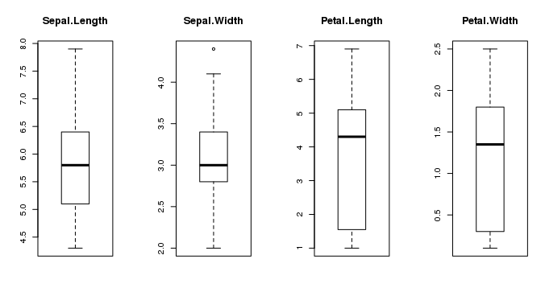

Box and Whisker Plots in R

We can also create a barplot of the Species class variable to get a graphical representation of the class distribution (generally uninteresting in this case because they’re even).

|  |  |
| --- | --- |
| 1  2 | # barplot for class breakdown  plot(y) |

This confirms what we learned in the last section, that the instances are evenly distributed across the three class:

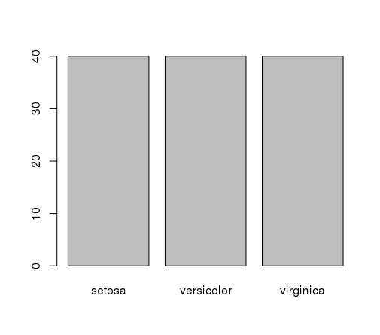

Bar Plot of Iris Flower Species

#### Multivariate Plots

Now we can look at the interactions between the variables.

First let’s look at scatterplots of all pairs of attributes and color the points by class. In addition, because the scatterplots show that points for each class are generally separate, we can draw ellipses around them.

|  |  |
| --- | --- |
| 1  2 | # scatterplot matrix  featurePlot(x=x, y=y, plot="ellipse") |

We can see some clear relationships between the input attributes (trends) and between attributes and the class values (ellipses):

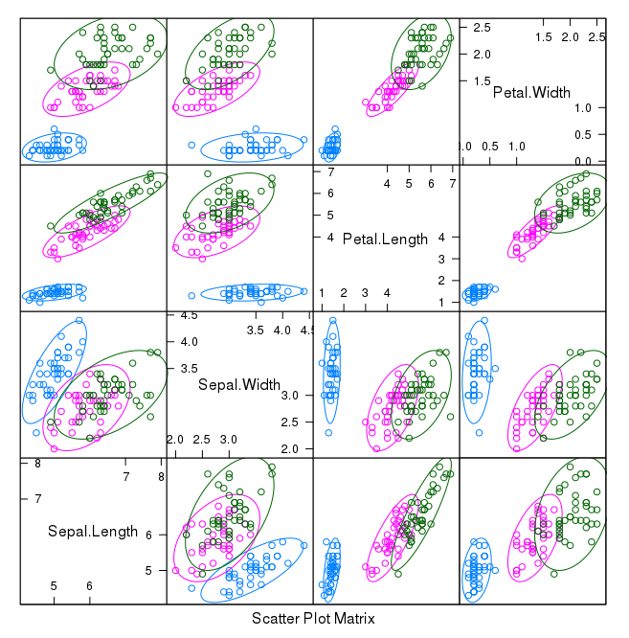

Scatterplot Matrix of Iris Data in R

We can also look at box and whisker plots of each input variable again, but this time broken down into separate plots for each class. This can help to tease out obvious linear separations between the classes.

|  |  |
| --- | --- |
| 1  2 | # box and whisker plots for each attribute  featurePlot(x=x, y=y, plot="box") |

This is useful to see that there are clearly different distributions of the attributes for each class value.

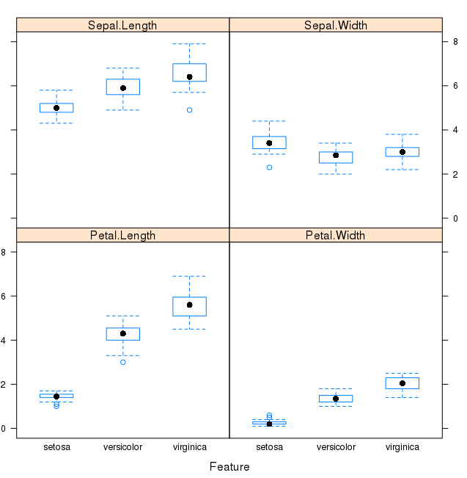

Box and Whisker Plot of Iris data by Class Value

Next we can get an idea of the distribution of each attribute, again like the box and whisker plots, broken down by class value. Sometimes histograms are good for this, but in this case we will use some probability density plots to give nice smooth lines for each distribution.

|  |  |
| --- | --- |
| 1  2  3 | # density plots for each attribute by class value  scales <- list(x=list(relation="free"), y=list(relation="free"))  featurePlot(x=x, y=y, plot="density", scales=scales) |

Like he boxplots, we can see the difference in distribution of each attribute by class value. We can also see the Gaussian-like distribution (bell curve) of each attribute.

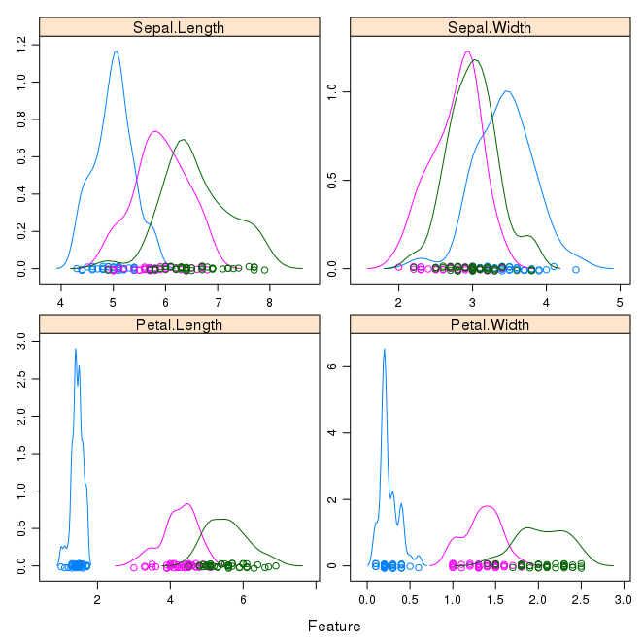

Density Plots of Iris Data By Class Value

### Evaluate Some Algorithms

Now it is time to create some models of the data and estimate their accuracy on unseen data.

Here is what we are going to cover in this step:

1. Set-up the test harness to use 10-fold cross validation.
2. Build 5 different models to predict species from flower measurements
3. Select the best model.

#### Test Harness

We will 10-fold crossvalidation to estimate accuracy.

This will split our dataset into 10 parts, train in 9 and test on 1 and release for all combinations of train-test splits. We will also repeat the process 3 times for each algorithm with different splits of the data into 10 groups, in an effort to get a more accurate estimate.

|  |  |
| --- | --- |
| 1  2  3 | # Run algorithms using 10-fold cross validation  control <- trainControl(method="cv", number=10)  metric <- "Accuracy" |

We are using the metric of “Accuracy” to evaluate models. This is a ratio of the number of correctly predicted instances in divided by the total number of instances in the dataset multiplied by 100 to give a percentage (e.g. 95% accurate). We will be using the metricvariable when we run build and evaluate each model next.

#### Build Models

We don’t know which algorithms would be good on this problem or what configurations to use. We get an idea from the plots that some of the classes are partially linearly separable in some dimensions, so we are expecting generally good results.

Let’s evaluate 5 different algorithms:

* Linear Discriminant Analysis (LDA)
* Classification and Regression Trees (CART).
* k-Nearest Neighbors (kNN).
* Support Vector Machines (SVM) with a linear kernel.
* Random Forest (RF)

This is a good mixture of simple linear (LDA), nonlinear (CART, kNN) and complex nonlinear methods (SVM, RF). We reset the random number seed before reach run to ensure that the evaluation of each algorithm is performed using exactly the same data splits. It ensures the results are directly comparable.

Let’s build our five models:

|  |  |
| --- | --- |
| 1  2  3  4  5  6  7  8  9  10  11  12  13  14  15  16  17 | # a) linear algorithms  set.seed(7)  fit.lda <- train(Species~., data=dataset, method="lda", metric=metric, trControl=control)  # b) nonlinear algorithms  # CART  set.seed(7)  fit.cart <- train(Species~., data=dataset, method="rpart", metric=metric, trControl=control)  # kNN  set.seed(7)  fit.knn <- train(Species~., data=dataset, method="knn", metric=metric, trControl=control)  # c) advanced algorithms  # SVM  set.seed(7)  fit.svm <- train(Species~., data=dataset, method="svmRadial", metric=metric, trControl=control)  # Random Forest  set.seed(7)  fit.rf <- train(Species~., data=dataset, method="rf", metric=metric, trControl=control) |

Caret does support the configuration and tuning of the configuration of each model, but we are not going to cover that in this tutorial.

#### Select Best Model

We now have 5 models and accuracy estimations for each. We need to compare the models to each other and select the most accurate.

We can report on the accuracy of each model by first creating a list of the created models and using the summary function.

|  |  |
| --- | --- |
| 1  2  3 | # summarize accuracy of models  results <- resamples(list(lda=fit.lda, cart=fit.cart, knn=fit.knn, svm=fit.svm, rf=fit.rf))  summary(results) |

We can see the accuracy of each classifier and also other metrics like Kappa:

|  |  |
| --- | --- |
| 1  2  3  4  5  6  7  8  9  10  11  12  13  14  15  16  17  18 | Models: lda, cart, knn, svm, rf  Number of resamples: 10    Accuracy         Min. 1st Qu. Median   Mean 3rd Qu. Max. NA's  lda  0.9167  0.9375 1.0000 0.9750       1    1    0  cart 0.8333  0.9167 0.9167 0.9417       1    1    0  knn  0.8333  0.9167 1.0000 0.9583       1    1    0  svm  0.8333  0.9167 0.9167 0.9417       1    1    0  rf   0.8333  0.9167 0.9583 0.9500       1    1    0    Kappa        Min. 1st Qu. Median   Mean 3rd Qu. Max. NA's  lda  0.875  0.9062 1.0000 0.9625       1    1    0  cart 0.750  0.8750 0.8750 0.9125       1    1    0  knn  0.750  0.8750 1.0000 0.9375       1    1    0  svm  0.750  0.8750 0.8750 0.9125       1    1    0  rf   0.750  0.8750 0.9375 0.9250       1    1    0 |

We can also create a plot of the model evaluation results and compare the spread and the mean accuracy of each model. There is a population of accuracy measures for each algorithm because each algorithm was evaluated 10 times (10 fold cross validation).

|  |  |
| --- | --- |
| 1  2 | # compare accuracy of models  dotplot(results) |

We can see that the most accurate model in this case was LDA:

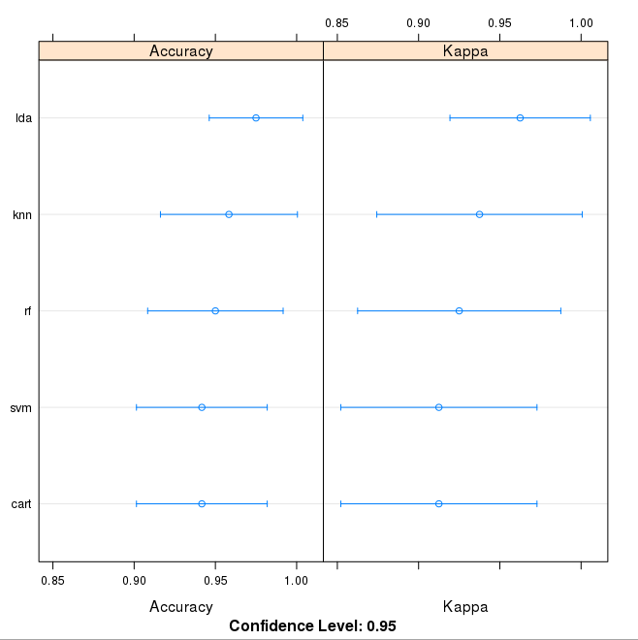

Comparison of Machine Learning Algorithms on Iris Dataset in R

The results for just the LDA model can be summarized.

|  |  |
| --- | --- |
| 1  2 | # summarize Best Model  print(fit.lda) |

This gives a nice summary of what was used to train the model and the mean and standard deviation (SD) accuracy achieved, specifically 97.5% accuracy +/- 4%

|  |  |
| --- | --- |
| 1  2  3  4  5  6  7  8  9  10  11  12  13 | Linear Discriminant Analysis    120 samples    4 predictor    3 classes: 'setosa', 'versicolor', 'virginica'    No pre-processing  Resampling: Cross-Validated (10 fold)  Summary of sample sizes: 108, 108, 108, 108, 108, 108, ...  Resampling results      Accuracy  Kappa   Accuracy SD  Kappa SD    0.975     0.9625  0.04025382   0.06038074 |

### Make Predictions

The LDA was the most accurate model. Now we want to get an idea of the accuracy of the model on our validation set.

This will give us an independent final check on the accuracy of the best model. It is valuable to keep a validation set just in case you made a slip during such as overfitting to the training set or a data leak. Both will result in an overly optimistic result.

We can run the LDA model directly on the validation set and summarize the results in a confusion matrix.

|  |  |
| --- | --- |
| 1  2  3 | # estimate skill of LDA on the validation dataset  predictions <- predict(fit.lda, validation)  confusionMatrix(predictions, validation$Species) |

We can see that the accuracy is 100%. It was a small validation dataset (20%), but this result is within our expected margin of 97% +/-4% suggesting we may have an accurate and a reliably accurate model.

|  |  |
| --- | --- |
| 1  2  3  4  5  6  7  8  9  10  11  12  13  14  15  16  17  18  19  20  21  22  23  24  25  26  27  28  29 | Confusion Matrix and Statistics                Reference  Prediction   setosa versicolor virginica    setosa         10          0         0    versicolor      0         10         0    virginica       0          0        10    Overall Statistics                   Accuracy : 1                   95% CI : (0.8843, 1)      No Information Rate : 0.3333      P-Value [Acc > NIR] : 4.857e-15                      Kappa : 1  Mcnemar's Test P-Value : NA    Statistics by Class:                         Class: setosa Class: versicolor Class: virginica  Sensitivity                 1.0000            1.0000           1.0000  Specificity                 1.0000            1.0000           1.0000  Pos Pred Value              1.0000            1.0000           1.0000  Neg Pred Value              1.0000            1.0000           1.0000  Prevalence                  0.3333            0.3333           0.3333  Detection Rate              0.3333            0.3333           0.3333  Detection Prevalence        0.3333            0.3333           0.3333  Balanced Accuracy           1.0000            1.0000           1.0000 |